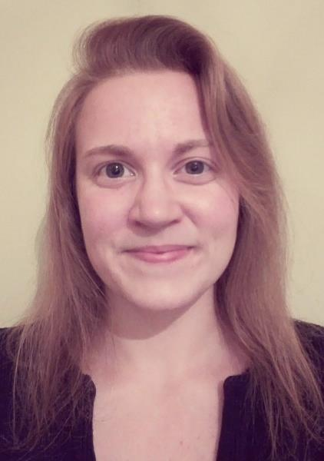
Who I am?
My name is Lucie, I’m a 22 years old student in Marine biotechnology and I come from Brittany, France.

My background
I have obtained in 2014 a BS degree in Biology specialty Biology/Earth and Universe Science (Bio-STU) at the University of Western Brittany (UBO; Brest, France). Then, I had the chance to integrate a MS in Biological Marine Sciences at the European Institute for Marine Studies (IUEM; Plouzané, France). I am currently in my second and last year in this same Institute. I chose the speciality “Valorization of Marine Biotechnology” (Valbiorem). Over this formation, it was presented to us how it is possible to valorize wastes of fishing, macro and microalgae or again sponges (It is some examples among many others) and their extracts which are a real source of ingredients and molecules that can be used in different fields as food, feed, cosmetics, pharmaceutic…
To validate this final year, we have to carry out a 5-6 months internship. I had no special requirements, but I wished rather find a placement in connection with Health applications. I discovered ESMB thank to one of our professor, who spoke to us about the fact that this organisation gathered placements offers throughout Europe. I didn’t plan to do my internship abroad but some subjects proposed interested me a lot so I decided to apply at four of them (one in Ireland, two in Germany and one in Sweden). I really did not think to have a chance to get one of them but against all odds, I received a positive answer from Ireland (which was my first choice). So, since early January and until the end of May, I do my placement within the Centre for Research in Medical Devices (CURAM) at the National University of Ireland, in Galway. My project is focus on the development of a polymeric replica of microalgae frustule as a next generation drug delivery system.

About ESMB initiative
I am really happy to have discovered this association, which is exactly in connection with my study fields, Marine biotechnology. Studying and coming from Brittany in France, I always had a very regional point of view of this field, because it is a region very connected with the sea and where many industries worked in direct link with valorization of marine products. But with ESMB, it opened me to the possibilities that exist likewise abroad, which I find very important. Moreover, provide opportunity for students to have easy access to a lot of placement offers across Europe is a great idea. It widely facilitates the approaches because the internship topics are provided by labs themselves, checked by ESMB, and then students have just to apply. It also permits having direct contacts with our potential future supervisors, which is really interesting whether we have some question or if we need some help to find accommodation.
In any case, thanks to ESMB I have the chance to live a truly amazing adventure in a country I always wanted to visit.

